**Mood:**

Dark

**Color Palette:** [**http://paletton.com/**](http://paletton.com/)

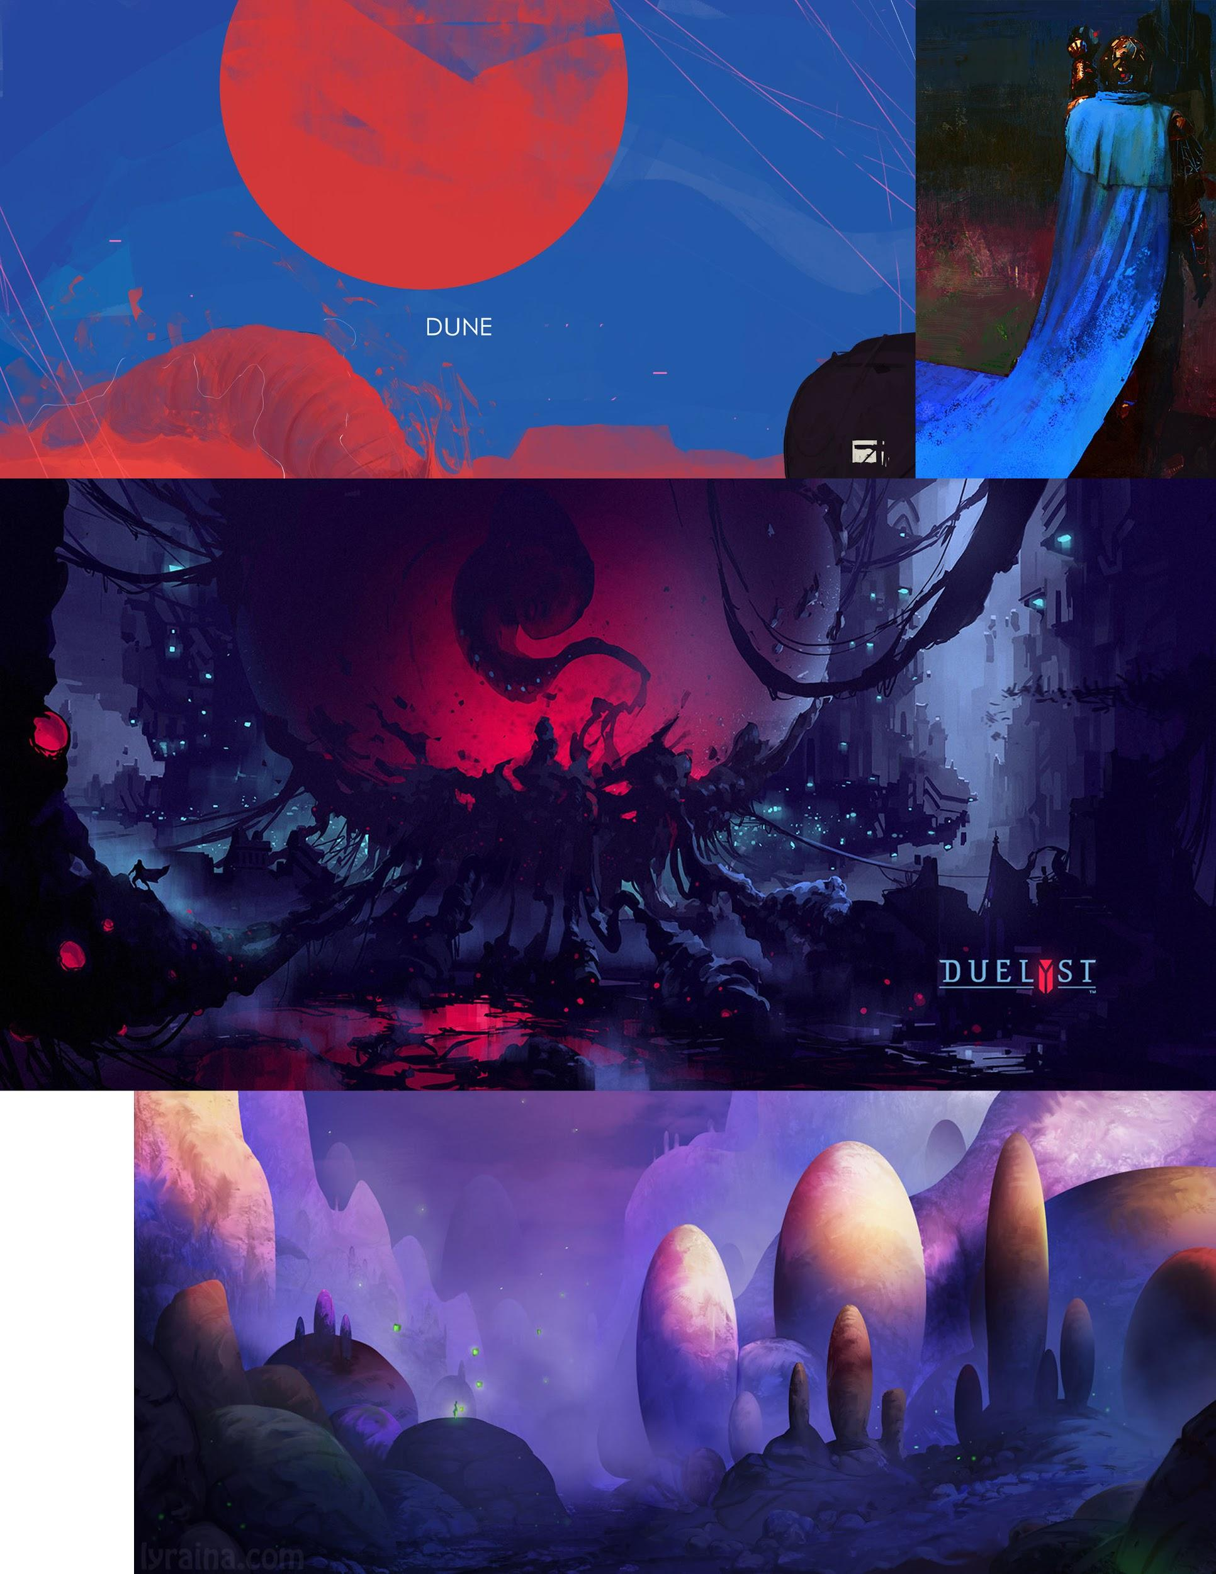

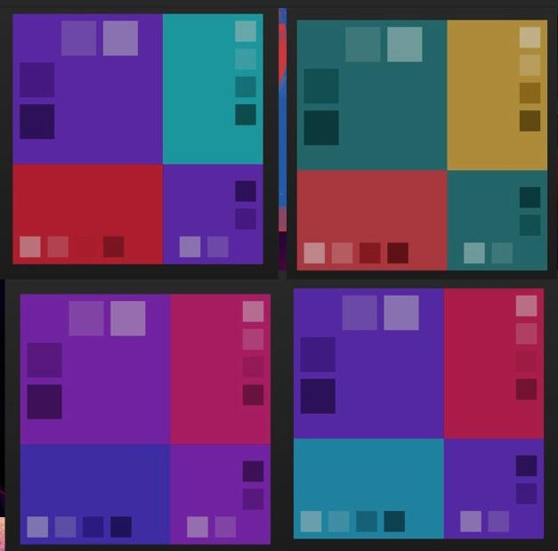

**Art Style:**

Character: (Cute and cuddle)

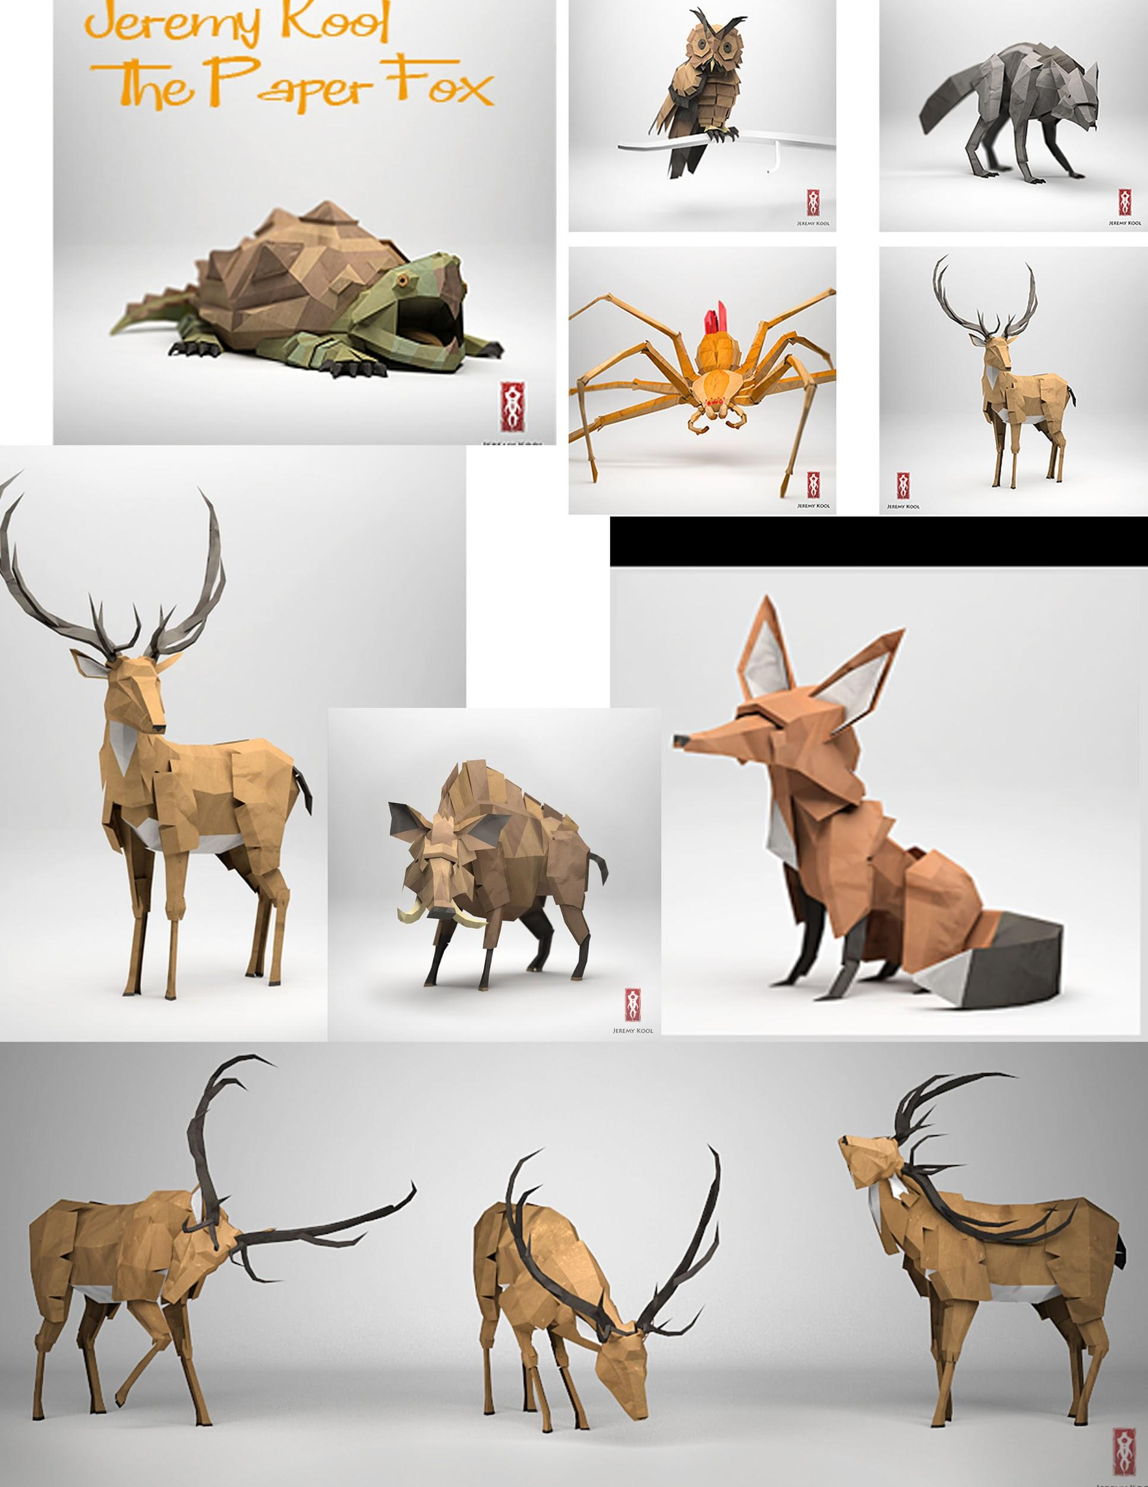

Enemies:

Environment:

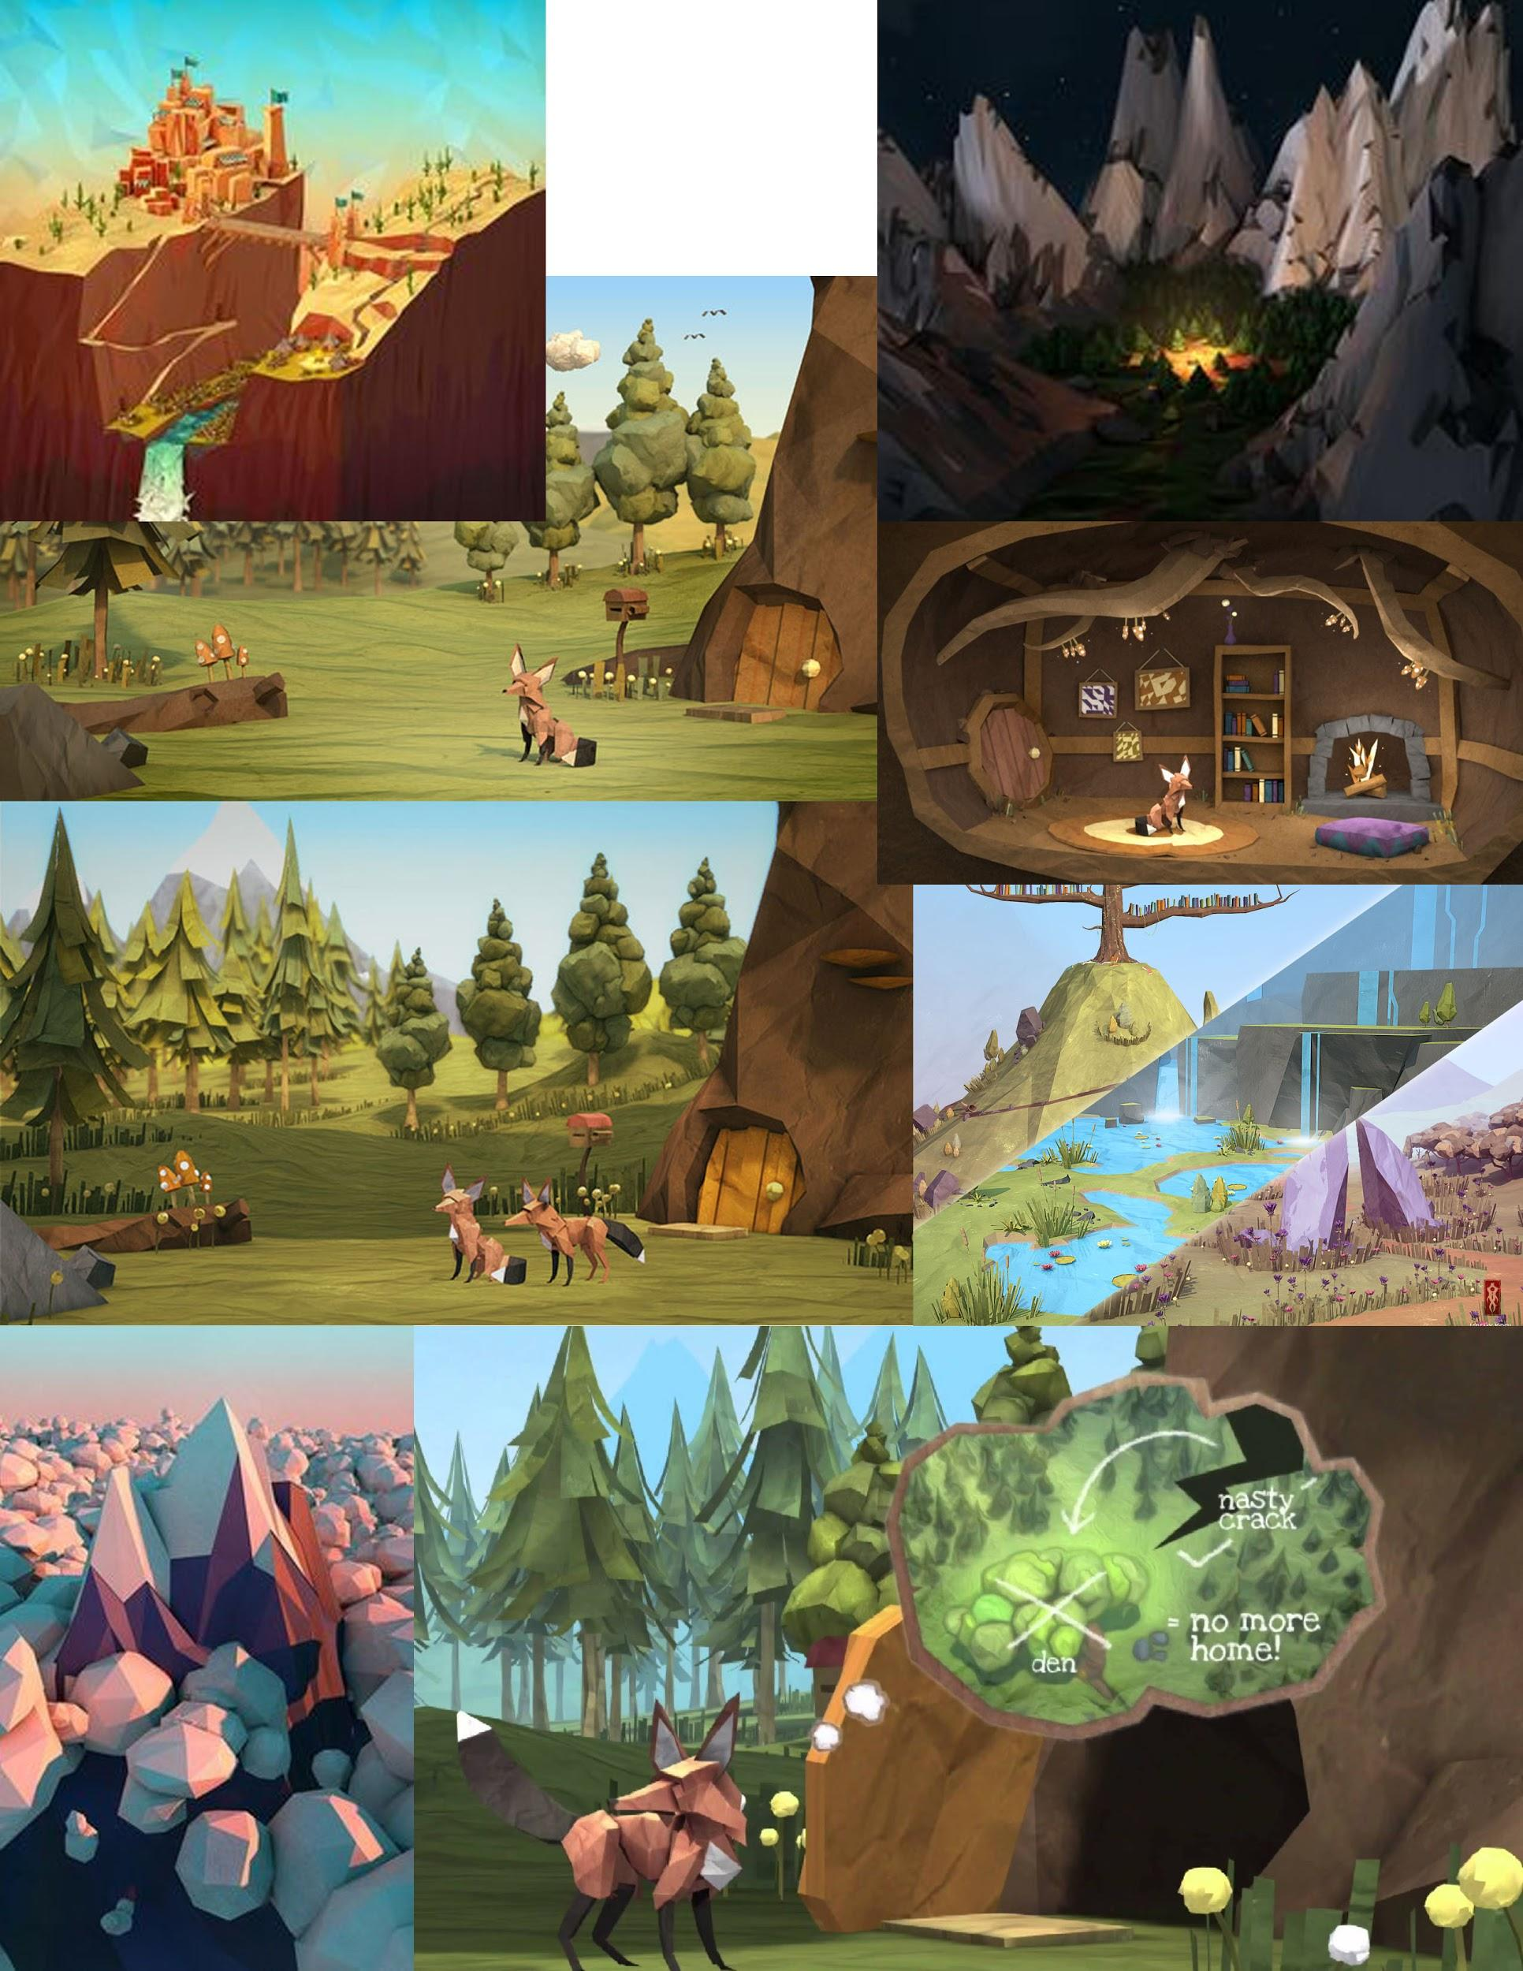

**UI:**

Start Screen:

Hud:

**Assets:**

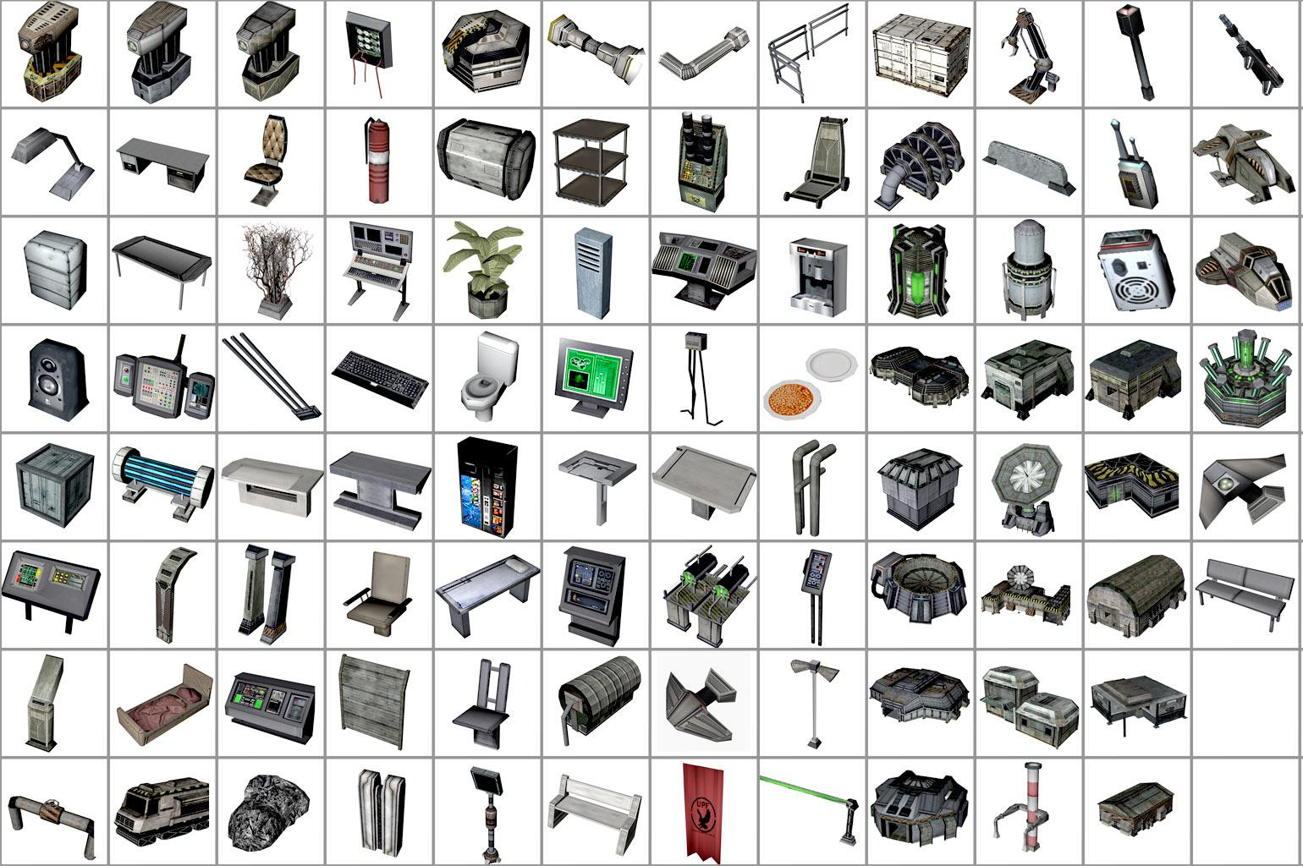

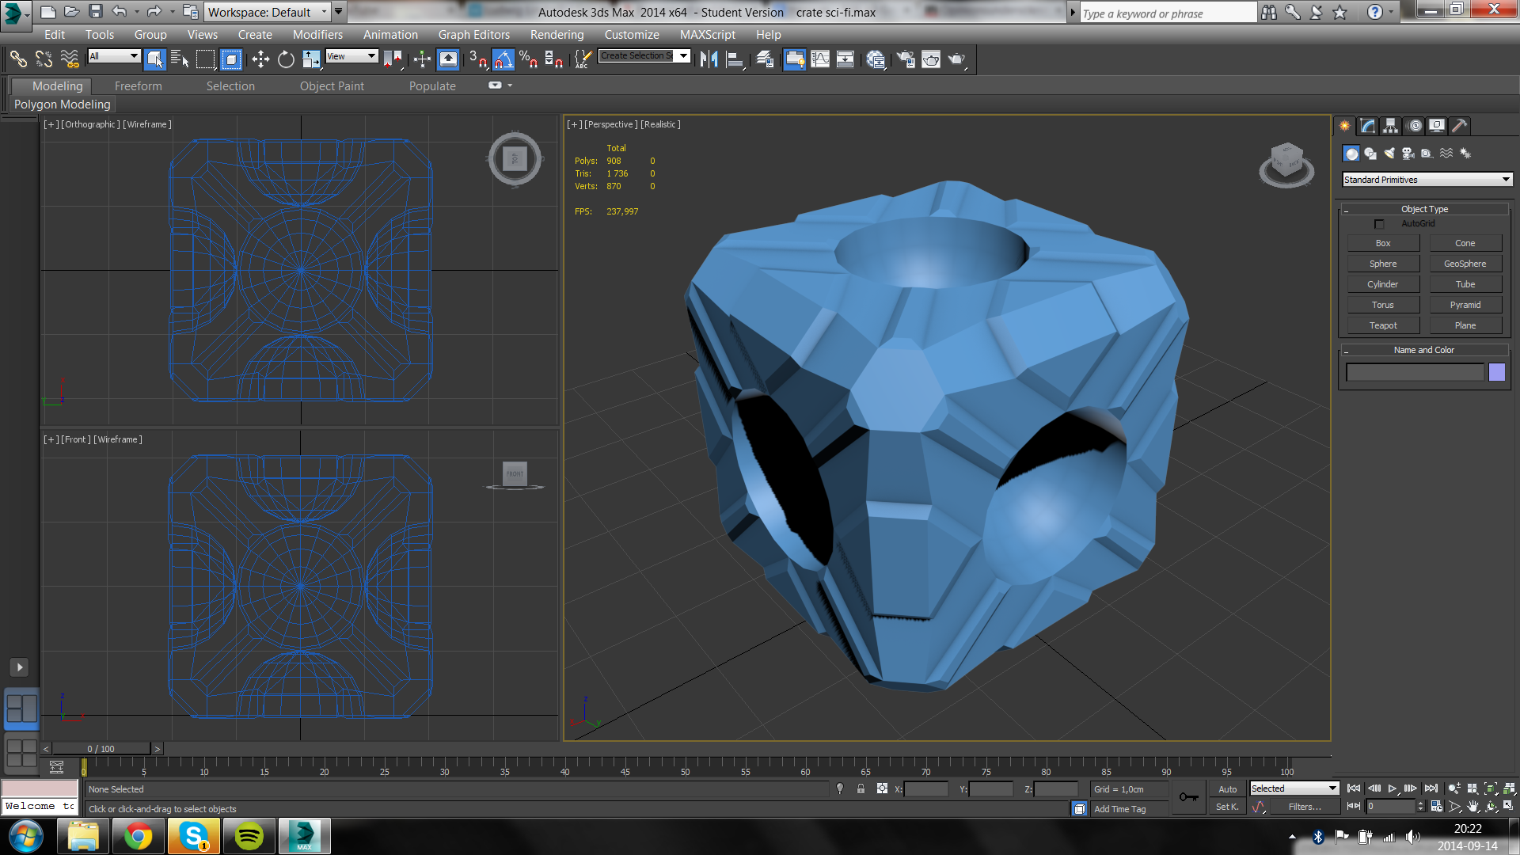



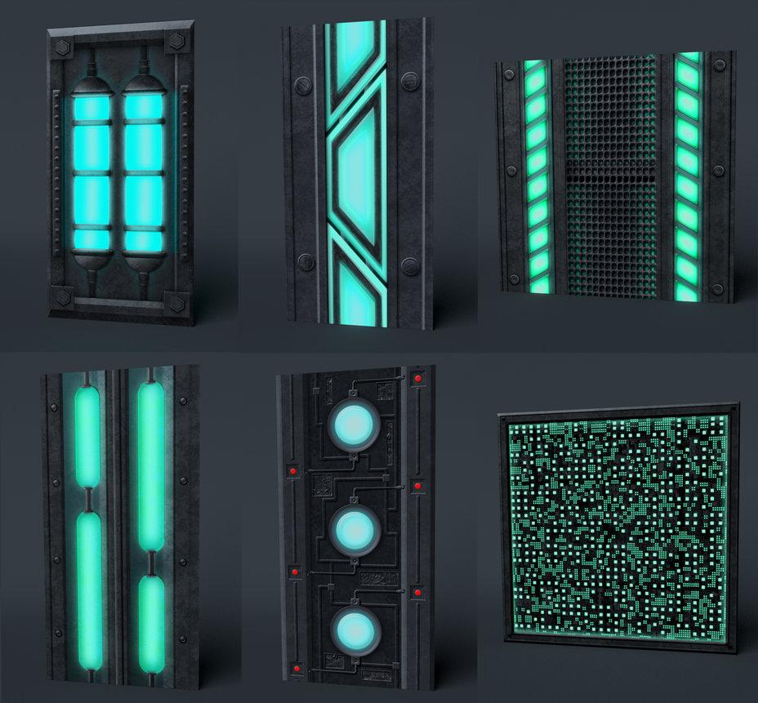

**Level Design:**

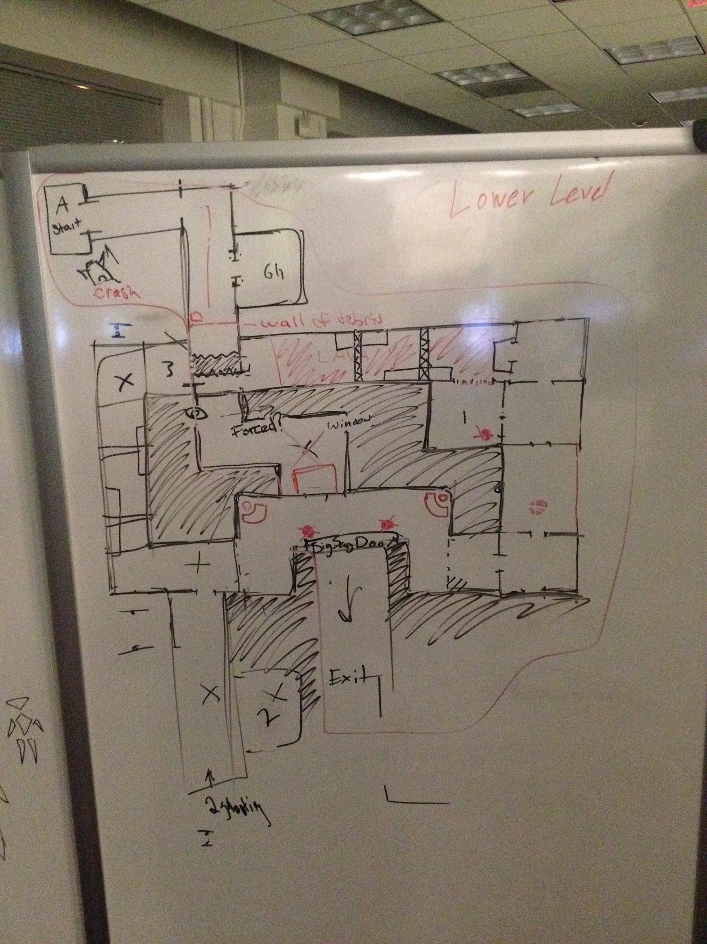

**Game examples:**

Alien Swarm

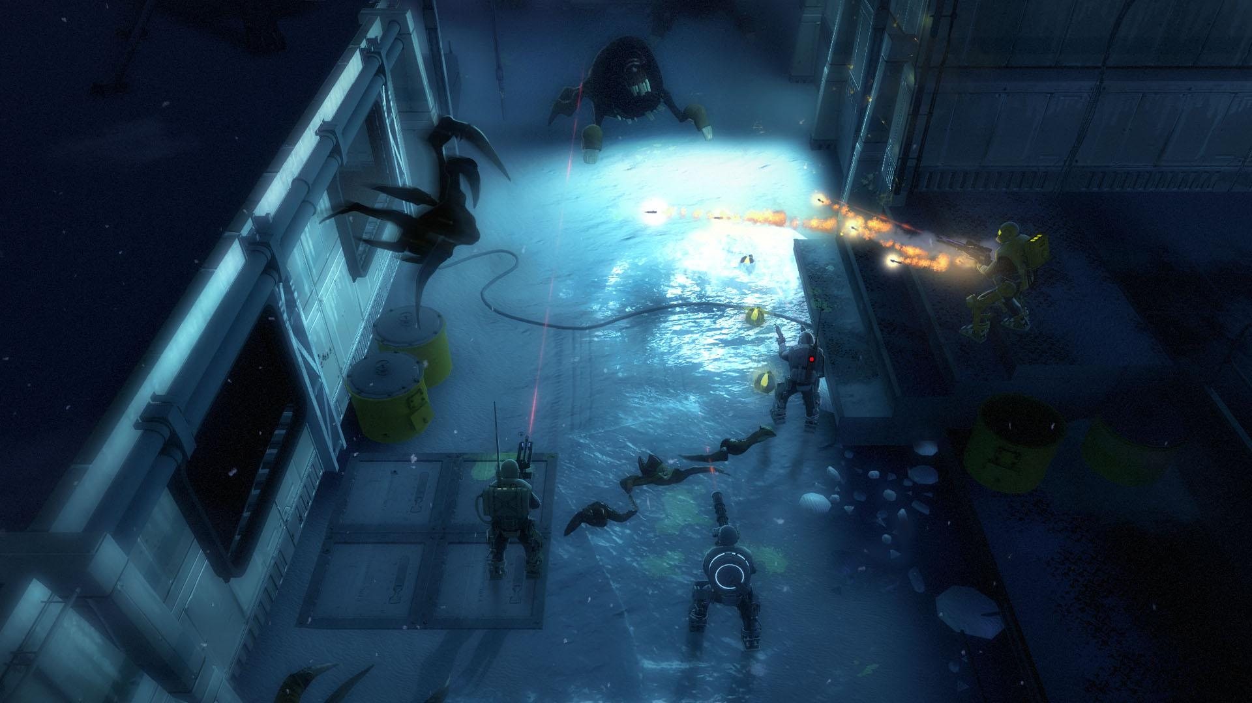

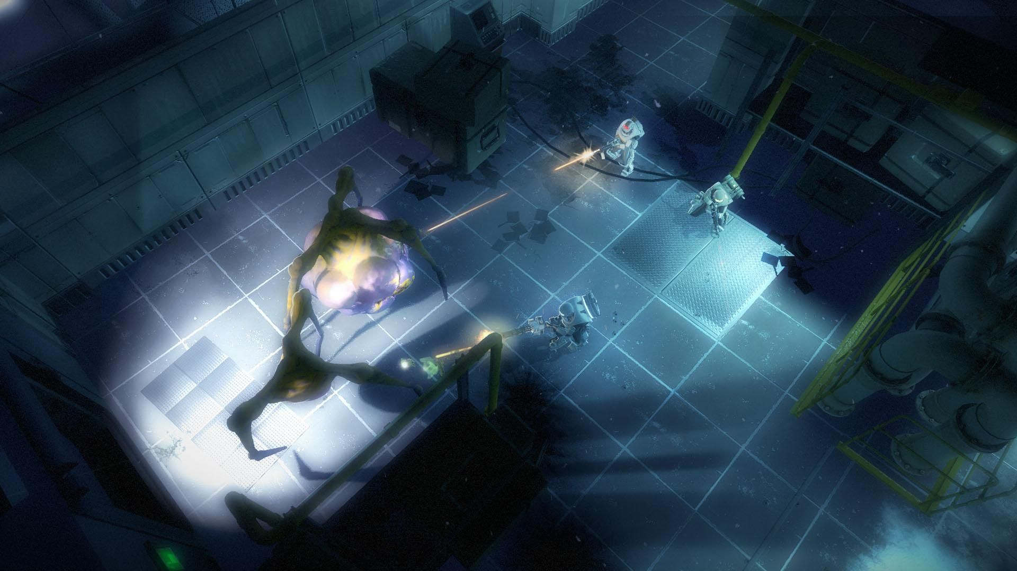

Contact Information

Mason Tubb 404-697-5926 [mason.tubb@gmail.com](mailto:mason.tubb@gmail.com)

Cara Windover 912-409-3227 [moocadoomi@gmail.com](mailto:moocadoomi@gmail.com)

Victoria Trac 843-813-0131 [victoriatrac@gmail.com](mailto:victoriatrac@gmail.com)

Kenny Oramasionwu 912-272-4095 [kenny.orams@gmail.com](mailto:kenny.orams@gmail.com)

Emily Kidd 470-345-1665 [eek3794@gmail.com](mailto:eek3794@gmail.com)

Megan Case 904-994-0893 [mecase223@gmail.com](mailto:mecase223@gmail.com)

Alex gregorie 678.209.4026 [alexgregorieart@gmail.com](mailto:alexgregorieart@gmail.com)